1.Map Design

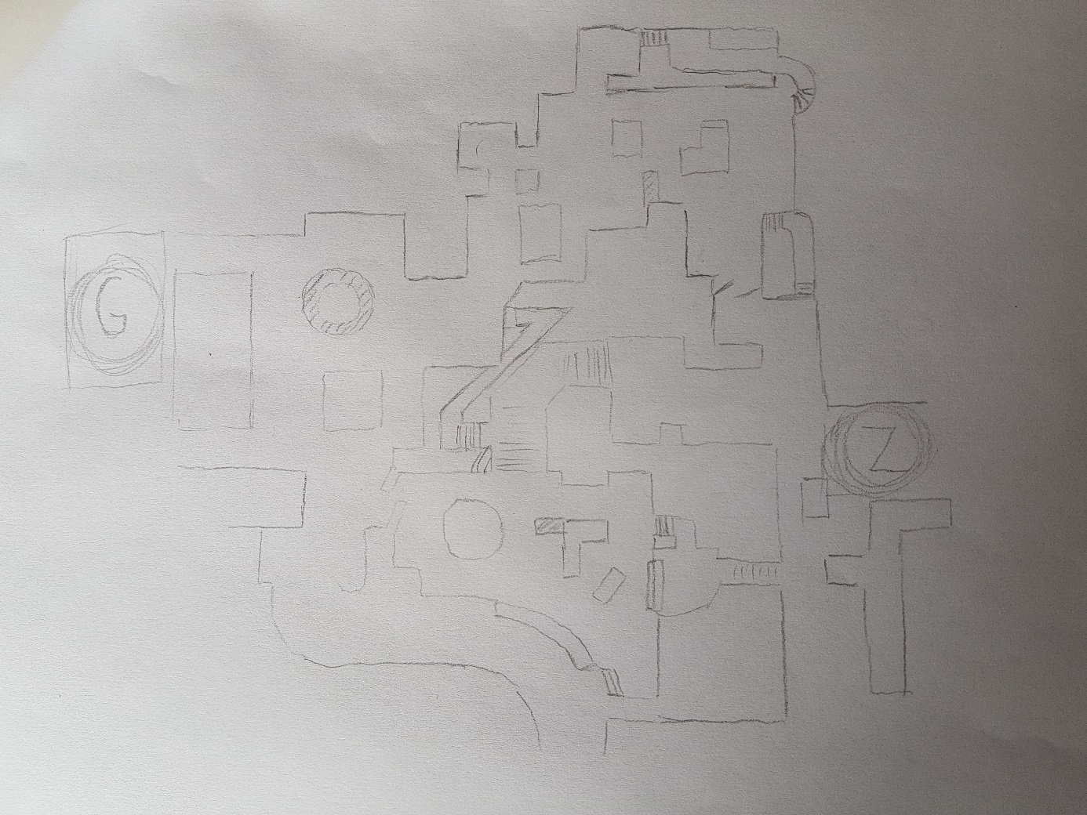

You can add more trenches, elevations or windows. However I try to make more simple.

The concept is town center after the doomsday. When you start to develop this concept, also help future battleground games.

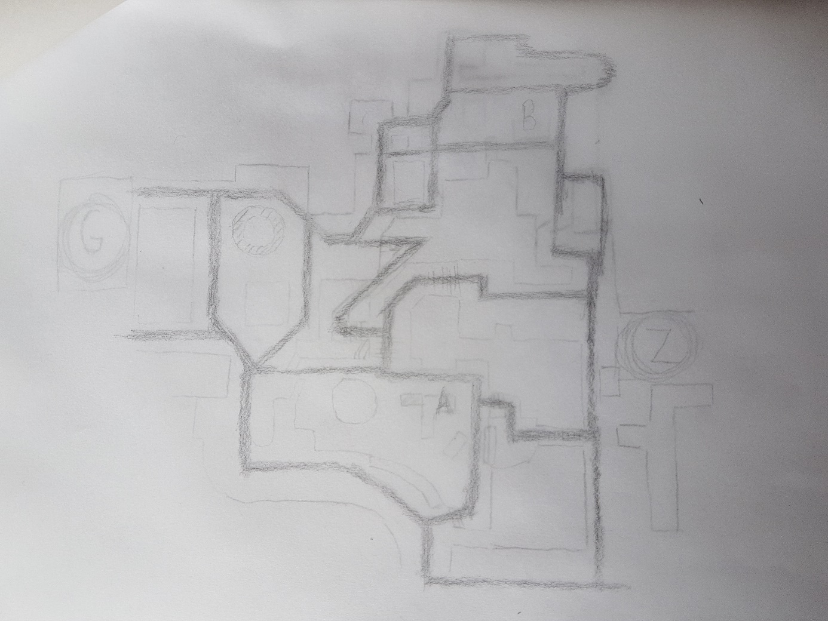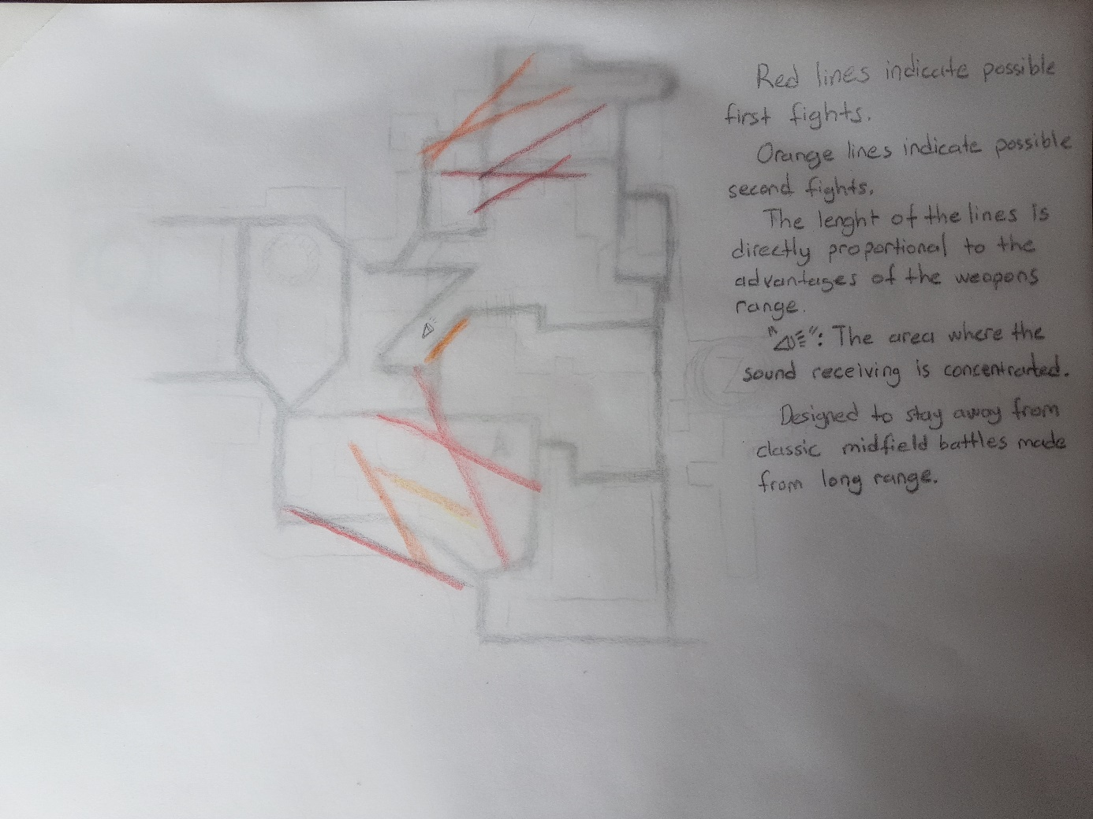

Bomb sides.

* Red lines indicate possible first fights.
* Orange lines indicate possible second fights.
* The lenght of the lines is directly proportional to the advantages of the weapons range.

Spawn area of bombers

Spawn area of defenders

This are can be removed with tests.

Connecters